Temperature Loss and Efficiency Testing

- Calculating radiative and conductive heat loss in an average homebrew setup
Methodology:
Utilising my current homebrewing equipment:
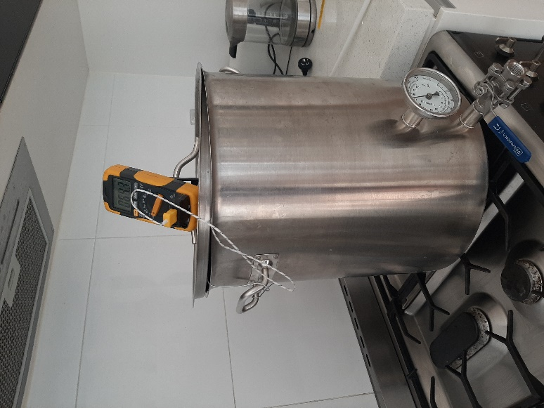
- 38L stainless steel brew kettle with lid
- Gas stovetop
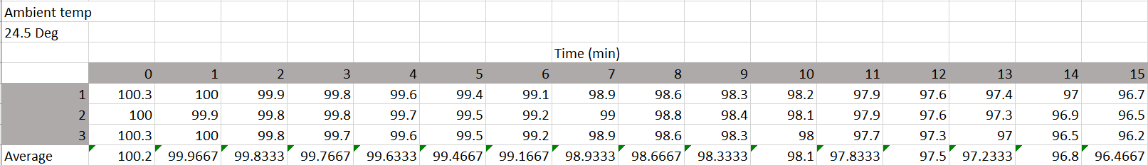
25L of water was added to the brew kettle and placed on the stovetop. The pot lid was left slightly ajar to allow some steam to escape the system (This is to emulate the design of our final system. A small steam vent will be included to prevent pressure building up within the vessel) The water was then heated to boil and maintained at this temperature for 2 minutes to ensure all liquid had reached a homogonous temperature. The gas stovetop was then turned off and the temperature of the water was recorded every minute using a multi-meter and temperature probe over the course of 15 minutes. This process was repeated 3 times.
Results:
Figure 1: Heat Loss from Boil

The above graph has an unexpected dip and plateau at the beginning. I believe the dip was due to the temperature being above 100⁰C (e.g. the probe was measuring steam temperature which stopped as soon as the heat source was removed). The plateau was most likely caused by the element (which was greater that 100⁰C) continuing to conduct heat to the brew kettle for a few minutes after the element was switched off. Because of both of these factors the beginning of our dataset is not useful for calculating the rate of heat loss due to conduction. The condensed dataset below begins at minute 4 to account for this.

Utilising a linear trendline (This seems to approximate heat loss at high temperatures. It is understood that the actual trendline would be logarithmic until the water reaches the ambient room temperature) The liner trendline works for our purpose as we are attempting to calculate heat lost to radiation at the highest temperature gradient (e.g., 100⁰C water radiating to 24.5⁰C ambient air). From the trendline we get the equation:
$y = -0.2876x+100.05$
This tells us that our system looses 0.2876⁰C per minute to passive radiation and conduction.
The specific heat capacity of water is 4,184 J/kg⁰C (Joules per kilogram per ⁰C). This means it takes 4,184J to raise 1L of water (1L = 1kg) by 1⁰C. The same amount of energy will be lost when 1L of water drops by 1⁰C.
To calculate the efficiency of our system we want to convert Joules to KWh.
$$KWh=J*2.777778*{10}^{-7} \\ KWh=\left(SHC*25L*{0.2876}^{0}C*60\right)*2.777778*{10}^{-7} \\ KWh=\left(4184*25*0.2876*60\right)*2.777778*{10}^{-7} \\ KWh= 0.501$$
This tells us that 501W of energy is lost to passive radiation and conduction in our “standard” setup with 25L of water at a near boil over the course of an hour.
This loss is representative of the “worst case scenario” i.e. at a maximum temperature gradient, and will be reduce proportionally to a lower system temperature. (We could possibly model this if required…?)
This energy loss could also be reduced through the use of insulating materials.
- Calculating Heat Loss in a Recirculation System
As radiative and conductive heat is lost at a rate proportional to surface area, we can estimate these losses based on an estimate of the surface area of our recirculation system.
The early design of our recirculation system will include approximately 1m of tubing at approximately 15mm diameter, pump, and some larger chambers for the sensor assemble and heater element. A fair estimate for the surface area of this system would be ≈ 1/3 of the surface area of the brew kettle. This results is a simple calculation of 1/3 * energy lost to passive radiation from the brew kettle.
$$KWh=\frac{1}{3}*0.501 \\ KWh=0.167$$

- Calculating Heat Loss Due to Boil-Off
During the boil, some of the wort will be converted to steam and lost out the vent. This results in energy lost from the system that has been used to convert the liquid to a gas (state change losses).
From my experience, I lose about 2.5L of water for a 25L batch during the boil stage to steam. I leave the lid completely off, however our system will most likely be designed to operate with the lid in place and a small vent to release some steam. This should result in a “boil-off-loss” similar to commercial all-in-one homebrew setups. Therefore we will use a loss rate of 7% for these calculations.
$$Boil Off=25*0.07 \\ Boil Off=1.75L$$
Water required 2,500,000 J/kg to change state from liquid to gas. We also want to convert this to KWh to calculate our efficiency.
$$KWh=J*2.777778*{10}^{-7} \\ KWh=\left(2,500,000J*1.75L\right)*{10}^{-7} \\ KWh=0.4375$$
This is a loss type that will predominantly occur during the boil phase and can therefore be ignored for calculating efficiency when not boiling the wort.

- Total Energy Loss of the System
Total energy loss during boil = Passive conduction and radiation losses of kettle + losses of recirculation line + state change losses
$$Total Energy Loss \left(at boil\right)=0.501+0.167+0.4375 \\ Total Energy Loss \left(at boil\right)=1.11KWh (2dp)$$
The total energy loss at any other stage will not include the state change losses and will also reduce proportional to a lower system temperature.
$$Total Energy Loss \left(at {99}^{0}C\right)=0.501+0.167 \\ Total Energy Loss \left({at 99}^{0}C\right)=0.67KWh (2dp)$$

To calculate the total energy loss at a specific temperature (or to heat to a specific temperature) a full model of our systems heat loss would need to be developed. This would involve further testing by following the methodology outlined in part 1, but by monitoring the temperature as it cools all the way from boiling to ambient room temperature.

- Conclusion
These results tell us that we need to utilise a heater element that is greater than 1.11KW to be able to maintain a boil. These results will also help us calculate time taken for a certain volume of wort to reach a specific temperature based on the wattage of the element by allowing us to calculate the efficiency of that element.
E.g. a 2KW element is used during the boil
$$Efficiency=1-\left(\frac{1.11}{2}\right) \\ Efficiency=44.5\%$$
E.g. a 2KW element is used at 99⁰C
$$Efficiency=1-\left(\frac{0.67}{2}\right) \\ Efficiency=66.5\%$$

- References
Online calculator for water boiling time
https://www.easycalculation.com/physics/thermodynamics/water-boiling-time-calculator.php
The specific heat capacity of wort (S.G. 1.061) seems to be around 14% less than that of water. This means that calculations taken from the above link will indicate an approximately 14% longer time to temp than what would be found when using wort.
https://www.homebrewtalk.com/threads/specific-heat-of-wort-a-scientific-approach.526781/
Specific heat capacity
https://en.wikipedia.org/wiki/Specific_heat_capacity
Boil-off losses
https://help.grainfather.com/hc/en-us/articles/360002141137-What-is-the-boil-off-rate-on-the-G30-
State change losses
https://www.theweatherprediction.com/habyhints2/524/

