Valves research
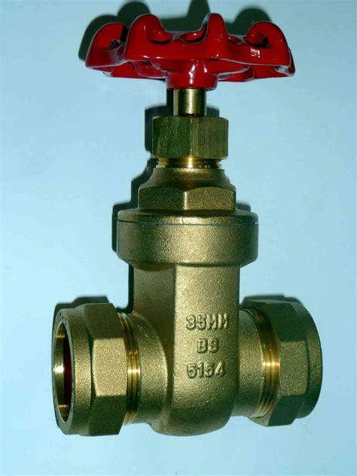
Gate Valve:
- Does not restrict flow rate when open.
- Does not cause water “hammering” when closing as closes slowly.
- Takes multiple turns to close therefore fine control.
- Straight-through flow

Pinch Valve:
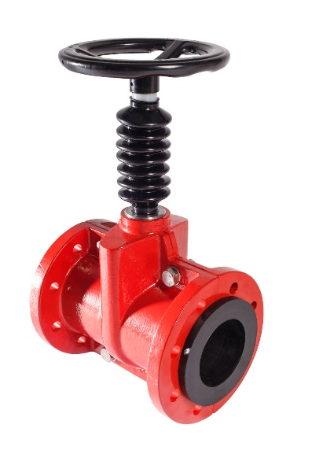
- Basically works like kinking a garden hose to stop the flow rate.
- Benefit of cleanliness, as there is no chance of leaving residue in the moving components of more standard valves.
- Possible issues with longevity?
- Good for applications with lots of suspended solids

Globe Valve:
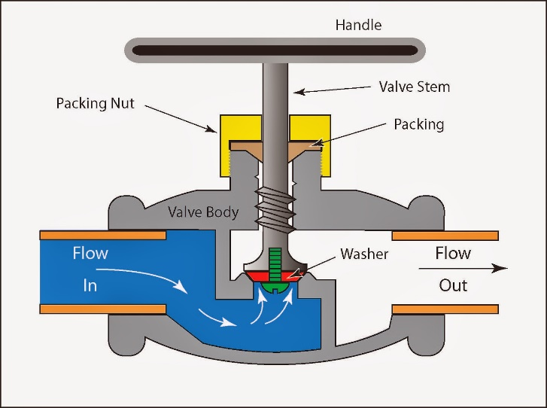
ADVANTAGES:
- Good shutoff capability
- Moderate to good throttling capability
- Shorter stroke (compared to a gate valve)
- Available in tee, wye, and angle patterns, each offering unique capabilities
- Easy to machine or resurface the seats
- With disc not attached to the stem, valve can be used as a stop-check valve

DISADVANTAGES:
- Higher pressure drop (compared to a gate valve)
- Requires greater force or a larger actuator to seat the valve (with pressure under the seat)
- Throttling flow under the seat and shutoff flow over the seat
“For applications with high temperature steam service, Globe valves are installed so that the pressure is above the disk. Otherwise, the stem will contract upon cooling and tend to lift the disk off the seat.”

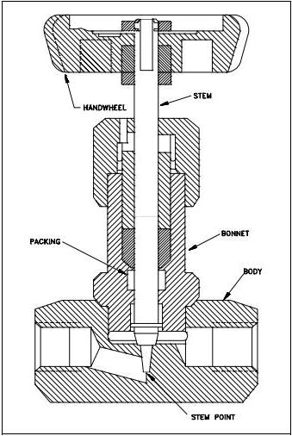
Needle Valves:
- Good for small lines
- Far more precise than any other valve type
- Small force required to operate
- Restricts flow rate when open more than other types of valve

